

Practices for Secure Software Report

Table of Contents
Document Revision History 3
Client 3
Instructions 3
Developer 4
1. Algorithm Cipher 4
2. Certificate Generation 4
3. Deploy Cipher 5
4. Secure Communications 5
5. Secondary Testing 7
6. Functional Testing 8
7. Summary 9
8. Industry Standard Best Practices 9

Document Revision History

Version | Date | Author | Comments
1.0 | [Date] | Arden Boykin

Client



Instructions

Submit this completed practices for secure software report. Replace the bracketed text with the relevant information. You must document your process for writing secure communications and refactoring code that complies with software security testing protocols.

- Respond to the steps outlined below and include your findings.
- Respond using your own words. You may also choose to include images or supporting materials. If you include them, make certain to insert them in all the relevant locations in the document.
- Refer to the Project Two Guidelines and Rubric for more detailed instructions about each section of the template.

Developer
Arden Boykin

Algorithm Cipher

I would recommend AES-256 (Advanced Encryption Standard with a 256-bit key) as the best cipher to use for Artemis Financial. AES-256 is a symmetric block cipher that takes a fixed 128-bit block of plaintext and transforms it through multiple rounds of mathematical operations using a secret key into a ciphertext block.
AES-256 goes through 14 rounds of processing to encrypt the data. Each round applies four transformations: SubBytes (where each byte is replaced with another according to a lookup table), ShiftRows (where the last three rows of the state are shifted cyclically a certain number of steps), MixColumns (where the four bytes in ach column are combined), and AddRoundKey (where each byte of the state is combined with a byte of the round key using bitwise XOR). AES-256 itself doesn't contain hash functions since it’s a block cipher, however a hash function can be implemented with Galois/Counter Mode (GCM) or used with a separate hash function like SHA-256, which is what is used in this project.
Randomness is necessary for AES deployment as the key used must be cryptographically random so that encrypting the same ciphertext twice does not produce the same ciphertext. This is usually done in the form of an initialization vector (IV), which can be implemented through something like the SecureRandom class in Java.
Historically, the National Institute of Standards and Technology (NIST) developed AES in 2001 to replace DES, and the algorithm hasn’t needed an update since then as its structure is still considered sound and strong enough to today’s standards. It’s availability in Oracle’s standard Java security library makes it easily accessible and a well proven secure option for Artemis Financial.

Certificate Generation
Insert a screenshot below of the CER file.

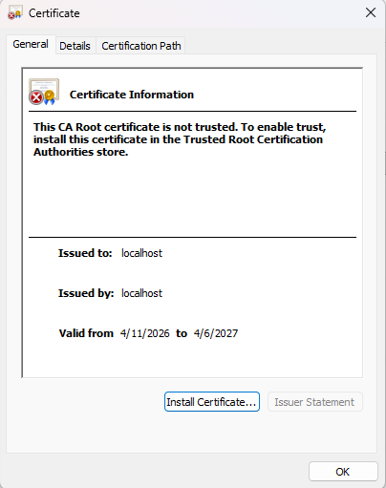

Deploy Cipher
Insert a screenshot below of the checksum verification.

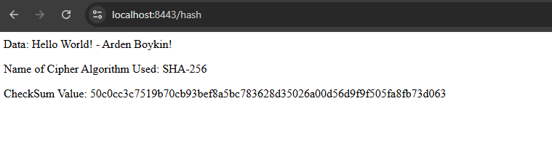

Secure Communications
Insert a screenshot below of the web browser that shows a secure webpage.
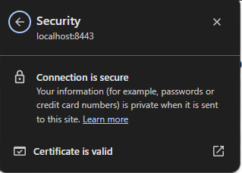
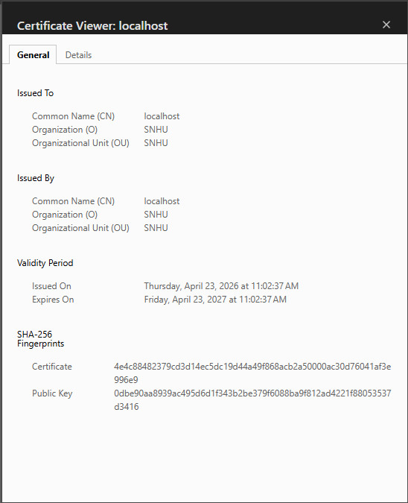

Secondary Testing
Insert screenshots below of the refactored code executed without errors and the dependency-check report.

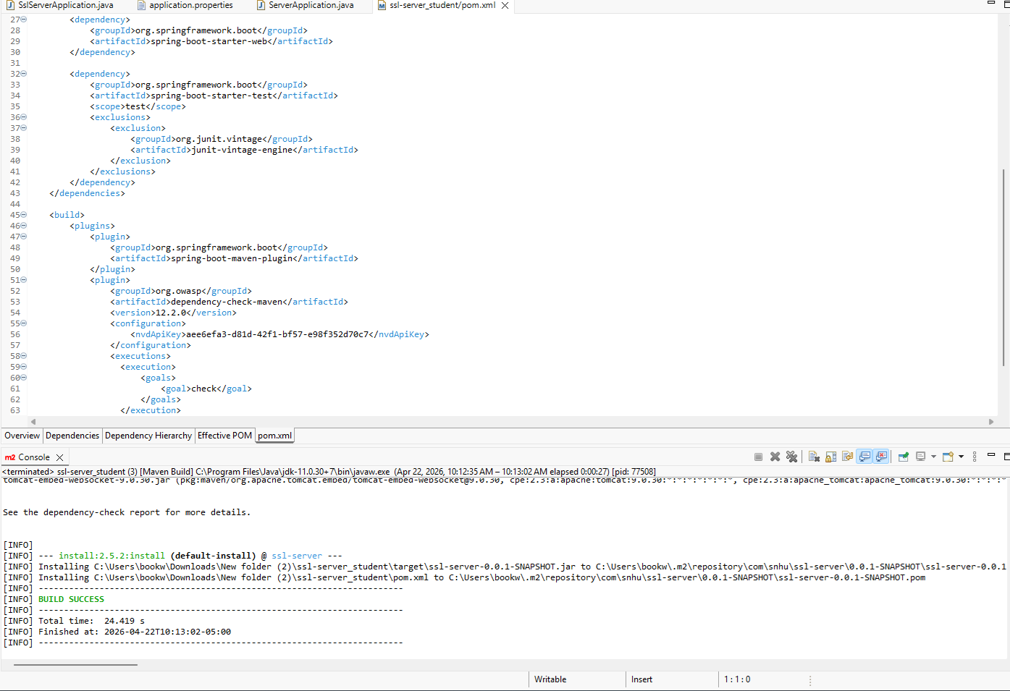
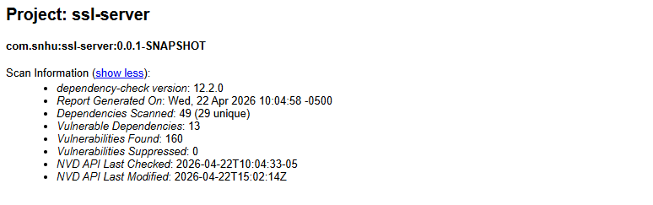

Functional Testing
Insert a screenshot below of the refactored code executed without errors.

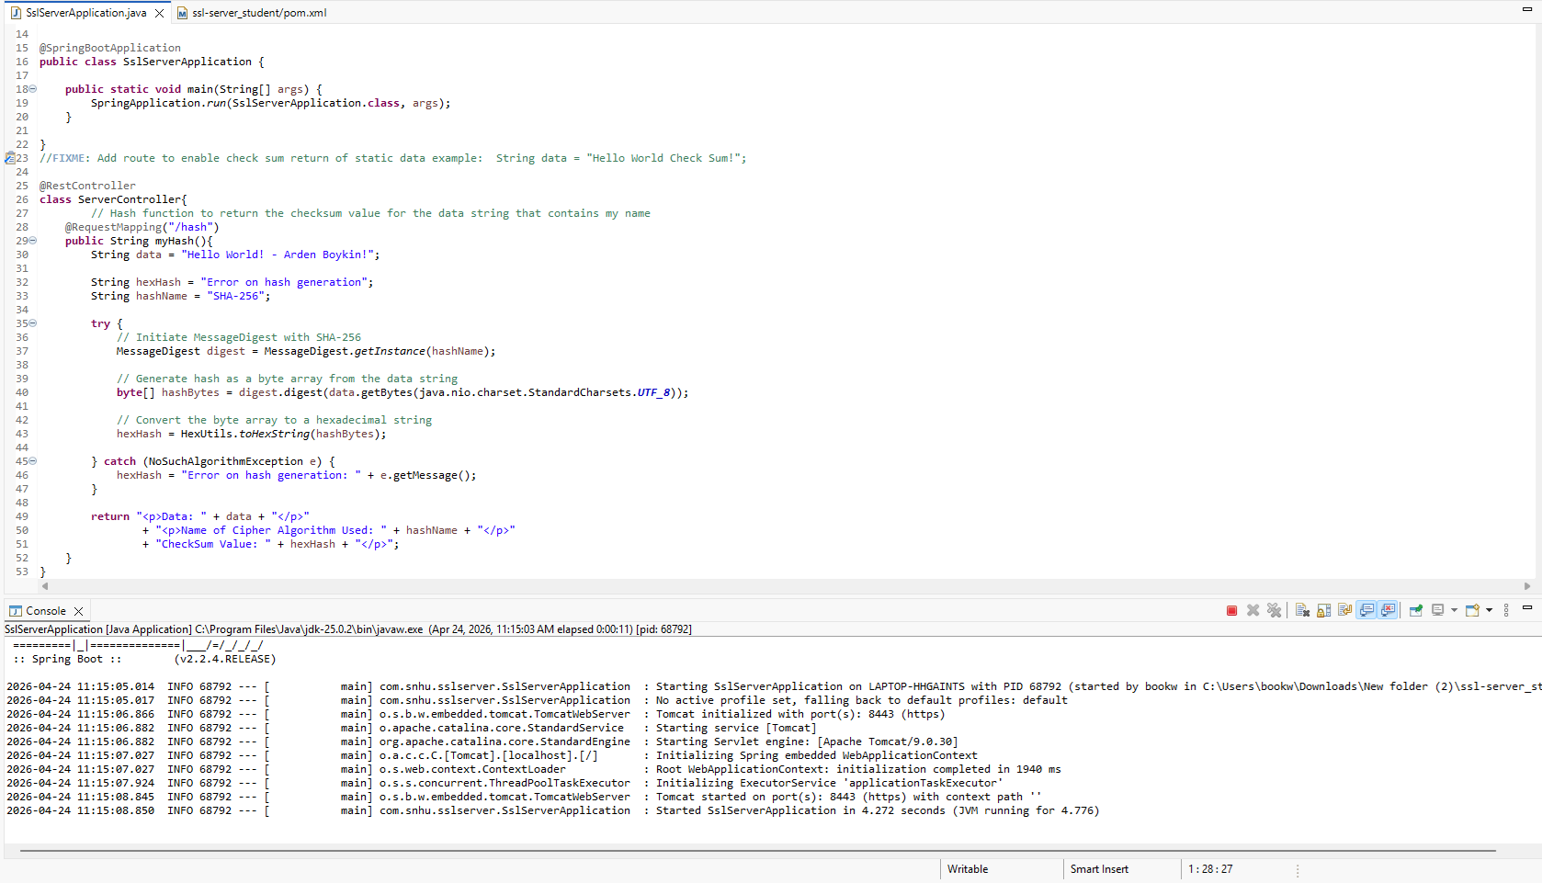

Summary

Adding security involved multiple layers and refactoring the code for the project addressed the cryptography, and code error areas of security.

The first layer focused on algorithm choice. SHA-256 was selected over weaker options like MD5 or SHA-1, which are now considered insecure. Cryptography was addressed by implementing SHA-256 encryption through the MessageDigest class.
The second layer focused on consistent encoding. By using StandardCharsets.UTF_8 when converting the data to bytes, the code avoids issues from default encoding on different platforms, which can create vulnerabilities.
The third layer focused on handling errors safely. Code error was addressed by wrapping the hashing logic of the encryption in a try/catch block with NoSuchAlgorithmExeption with a specific error message. This makes sure that the app fails in a controlled way instead of exposing sensitive data that can be exploited later.
The fourth layer focused on reviewing/testing the code and making sure it was well written. Code quality was addressed by structuring the ServerController class with best practices.

Industry Standard Best Practices

Best practices applied to the project during refactoring included:
- Using SHA-256 for the encryption
  - The NIST recommends SHA-2 family algorithms for hashing, which includes SHA-256.
- Adding the specification of StandardCharsets.UTF_8 when converting the data string
  - This eliminates ambiguity and future errors in the code that could be caused by default encoding on different platforms.
- Implementing the try/catch block to make sure that only a custom error message is sent to the user
  - This prevents stack traces and/or system details being leaked which can give malicious actors data to exploit.
- Adding comments and focusing on readability along with functionality
  - The code includes descriptive comments, steps within the method are separated for easy readability, and proper naming techniques are used.

Applying best practices in coding is important for a number of reasons. Following guidelines from organizations such as NIST and OWASP helps to maintain safe code which is essential in maintaining compliance with federal regulations and lowers risk for the company. Financially, preventing vulnerabilities is also less costly than having to fix the aftermath of an attack or breach of data. Generally, secure coding practices also help keep code structured and easier to maintain, which saves time when reviewing, implementing, or growing projects later on.

